FOR IMMEDIATE RELEASE
Contact: Anne Ladewig 202-266-8673 aladewig@nahb.org www.nahb.org
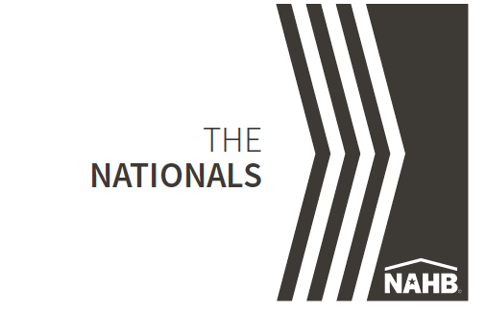

NAHB N The NationalsSM
Gold Award Winners Annual Honors Recognize Excellence in New Home Sales, Marketing and Design

ORLANDO, Jan. 9 - The year's most outstanding work in residential real estate sales, marketing and design was honored by the National Association of Home Builders (NAHB) at the National Sales and Marketing Awards gala (known as " The NationalsSM"), one of the building industry's most prestigious events. Hosted by the NAHB National Sales and Marketing Council, the event took place on Jan. 9 in Orlando at the 2018 International Builders' Show.

" The NationalsSM are the most prestigious awards of their kind, setting the benchmark for innovation in new home design, marketing and sales," said Kerry Mulcrone, chairperson of The NationalsSM. "NAHB's commitment to recognizing originality, imagination and success has been exemplified by its award winners since the competition's inception."
A diverse panel of industry professionals from across the country selected Gold award winners from more than 1,300 entries. Several top award winners are highlighted below.

ATTACHED COMMUNITY OF THE YEAR

Avora at Port Imperial
Weehawken, NJ
Builder: Landsea Homes
Marketing Director: Gabe Pasquale
Ad Agency- New World Group, Inc.
Architect- IBI Group
Interiors: IDA Associates

DETACHED COMMUNITY OF THE YEAR

Skye Palm Springs

Palm Springs, CA

Builder: Woodbridge Pacific Group

Marketing Director: Karen Spargo

Ad Agency: Roxburgh

Architect: Hannouche Architects

Interiors: Chameleon Design

Landscape: Professional Design Associates

Signage: Outdoor Dimensions

Master Planned Community of the Year
Vertical

Ward Village
Honolulu, Hawaii
Builder: Howard Hughes Corporation
Marketing Director: Bill Pisetsky
Architects: James K. M. Cheng, Rob Iopa, Solomon Cordwell Buenz,
WCIT Architecture, Ben Woo Architects, Richard Meier & Partners

Master Planned Community of the Year

Riverstone
Madera, CA
Builder: Riverstone Development LLC
Marketing Director: Nick Bruno
Ad Agency: InterCommunicationsInc
Interior Design: Chameleon Design
Landscape Design: Terry Broussard Broussard & Associates

INDIVIDUAL ACHIEVEMENT HONORS

Rookie Sales Person of The Year
Karen Smith
Ultimate New Home Sales & Marketing, Inc.
Tustin, CA

Sales Person of The Year
Graig Lee
Toll Brothers
Irvine, CA

Sales Team of the Year
Marianne Del Giudice, Yanny Lee and Tania Waheed
International Home Marketing Group
Toronto, Ontario Canada

Sales Manager of the Year
Jodi Palin
Summit Homes
Lee's Summit, MO

Marketing Professional of the Year
Jennifer Cooper
Oakwood Homes
Denver, CO

Online Sales Counselor of the Year
Laura Ellis
HHHunt Homes
Virginia, NC

Lifestyle Director of the Year
Monaca Onstad
Lakewood Ranch Communities
Sarasota, FL

For a complete list of Gold and Silver winners, along with additional details and history of The Nationals, please visit www.thenationals.com.
The exclusive co-sponsor of The Nationals is Wells Fargo Home Mortgage.
For more information, e-mail Lisa Parrish, lparrish@thenationals.com, or call her at 800-658-2751 or 909-987-2758.

#####
ABOUT NSMC: The National Sales and Marketing Council has been promoting professionalism in sales and marketing in the home building industry for 50 years. To help builders sell homes more effectively, the council provides onsite sales and marketing training; offers awards, recognition and designation programs; and provides sales and marketing support to NAHB members, committees and councils. The council serves 3,700 NSMC members and supports 75 local sales and marketing councils across the United States. For more information, visit www.nahb.org/nsmc.

ABOUT NAHB: The National Association of Home Builders is a Washington-based trade association representing more than 140,000 members involved in home building, remodeling, multifamily construction, property management, subcontracting, design, housing finance, building product manufacturing and other aspects of residential and light commercial construction. NAHB is affiliated with 800 state and local home builders associations around the country. NAHB's builder members will construct about 80 percent of the new housing units projected for this year.

