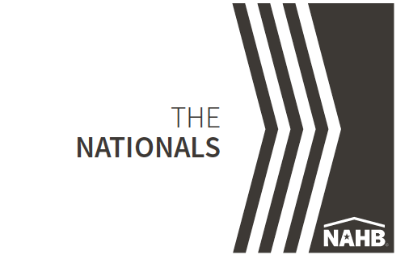
NAHB Announces National Sales and Marketing Silver Award Winners

NAHB’s National Sales and Marketing Council (NSMC) has announced the 2023 Silver Award Winners for The Nationals new home sales and marketing awards.

(Company name) received Silver Award honors for (category name).
(Paragraph 3 - briefly describe category and winner)
The Nationals salute and honor the best in the building industry — including home builders, developers, associates and consultants — for their determination, integrity, creativity and endurance.

Silver Award Winners are selected by a panel of judges who determine the top entries in each award category. Silver Award Winners are now finalists for The Nationals Gold Awards, which will be presented Feb. 27, 2024, in Las Vegas during the International Builders’Silver Award Winners are the top vote recipients in each award category and are the finalists for the Gold Award. Gold Awards in each category will be presented on ruary.January 31 in Las Vegas, NV.

“The Nationals’ award winners set the standard for excellence in new home sales, marketing and design,” said Allen Oliver, chairperson of The Nationals and CFO at Meredith Communications. “These prestigious awards have represented NAHB’s dedication to recognizing innovation, creativity and success for more than 40 years.”

Started in 1982 as the Institute of Residential Marketing, The Nationals award program recognizes superior new home sales and marketing achievements. , The awards honor excellence in product and community design, advertising, marketing and sales by individuals and teams across 61 categories spanning various disciplines of the new home industry.

During a four-day judging process, a panel of 13 industry professionals from across the country determined the Silver and Gold Award Winners from a field of more than 1,200 entries.

The Nationals are co-sponsored by Wells Fargo Home Mortgage.

To view Silver Award Winners and order tickets to the awards ceremony, visit thenationals.com.

For more information, email Lisa Parrish, or call 800-658-2751 or 909-987-2758.

